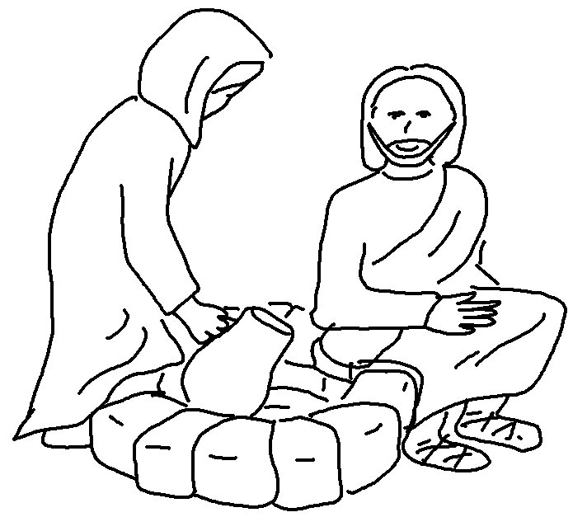
Let your good deeds shine out for all to see.

Matthew 5:16 _{NLT}

